7th December 2022

Dear Parents/Carers

CHANGE OF REGISTERED COMPANY NAME AS OF 6th DECEMBER 2022

The purpose of this letter is to inform you that following a Member’s resolution, our West Lakes Multi-Academy Trust has recently changed its registered and trading name to Changing Lives Learning Trust.

This is simply a change in the Trust’s overarching company name and logo; there is no change to any of the details for your child’s school.

Whilst the websites will be updated to reflect the change of name, your child’s academy email addresses and contact details will not be changing until early in the New Year and we will be in touch nearer the time with further details regarding this.

Thank you again to all who have contributed to this work.

Yours sincerely

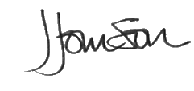

Jonathan Johnson OBE
Chief Executive Officer

