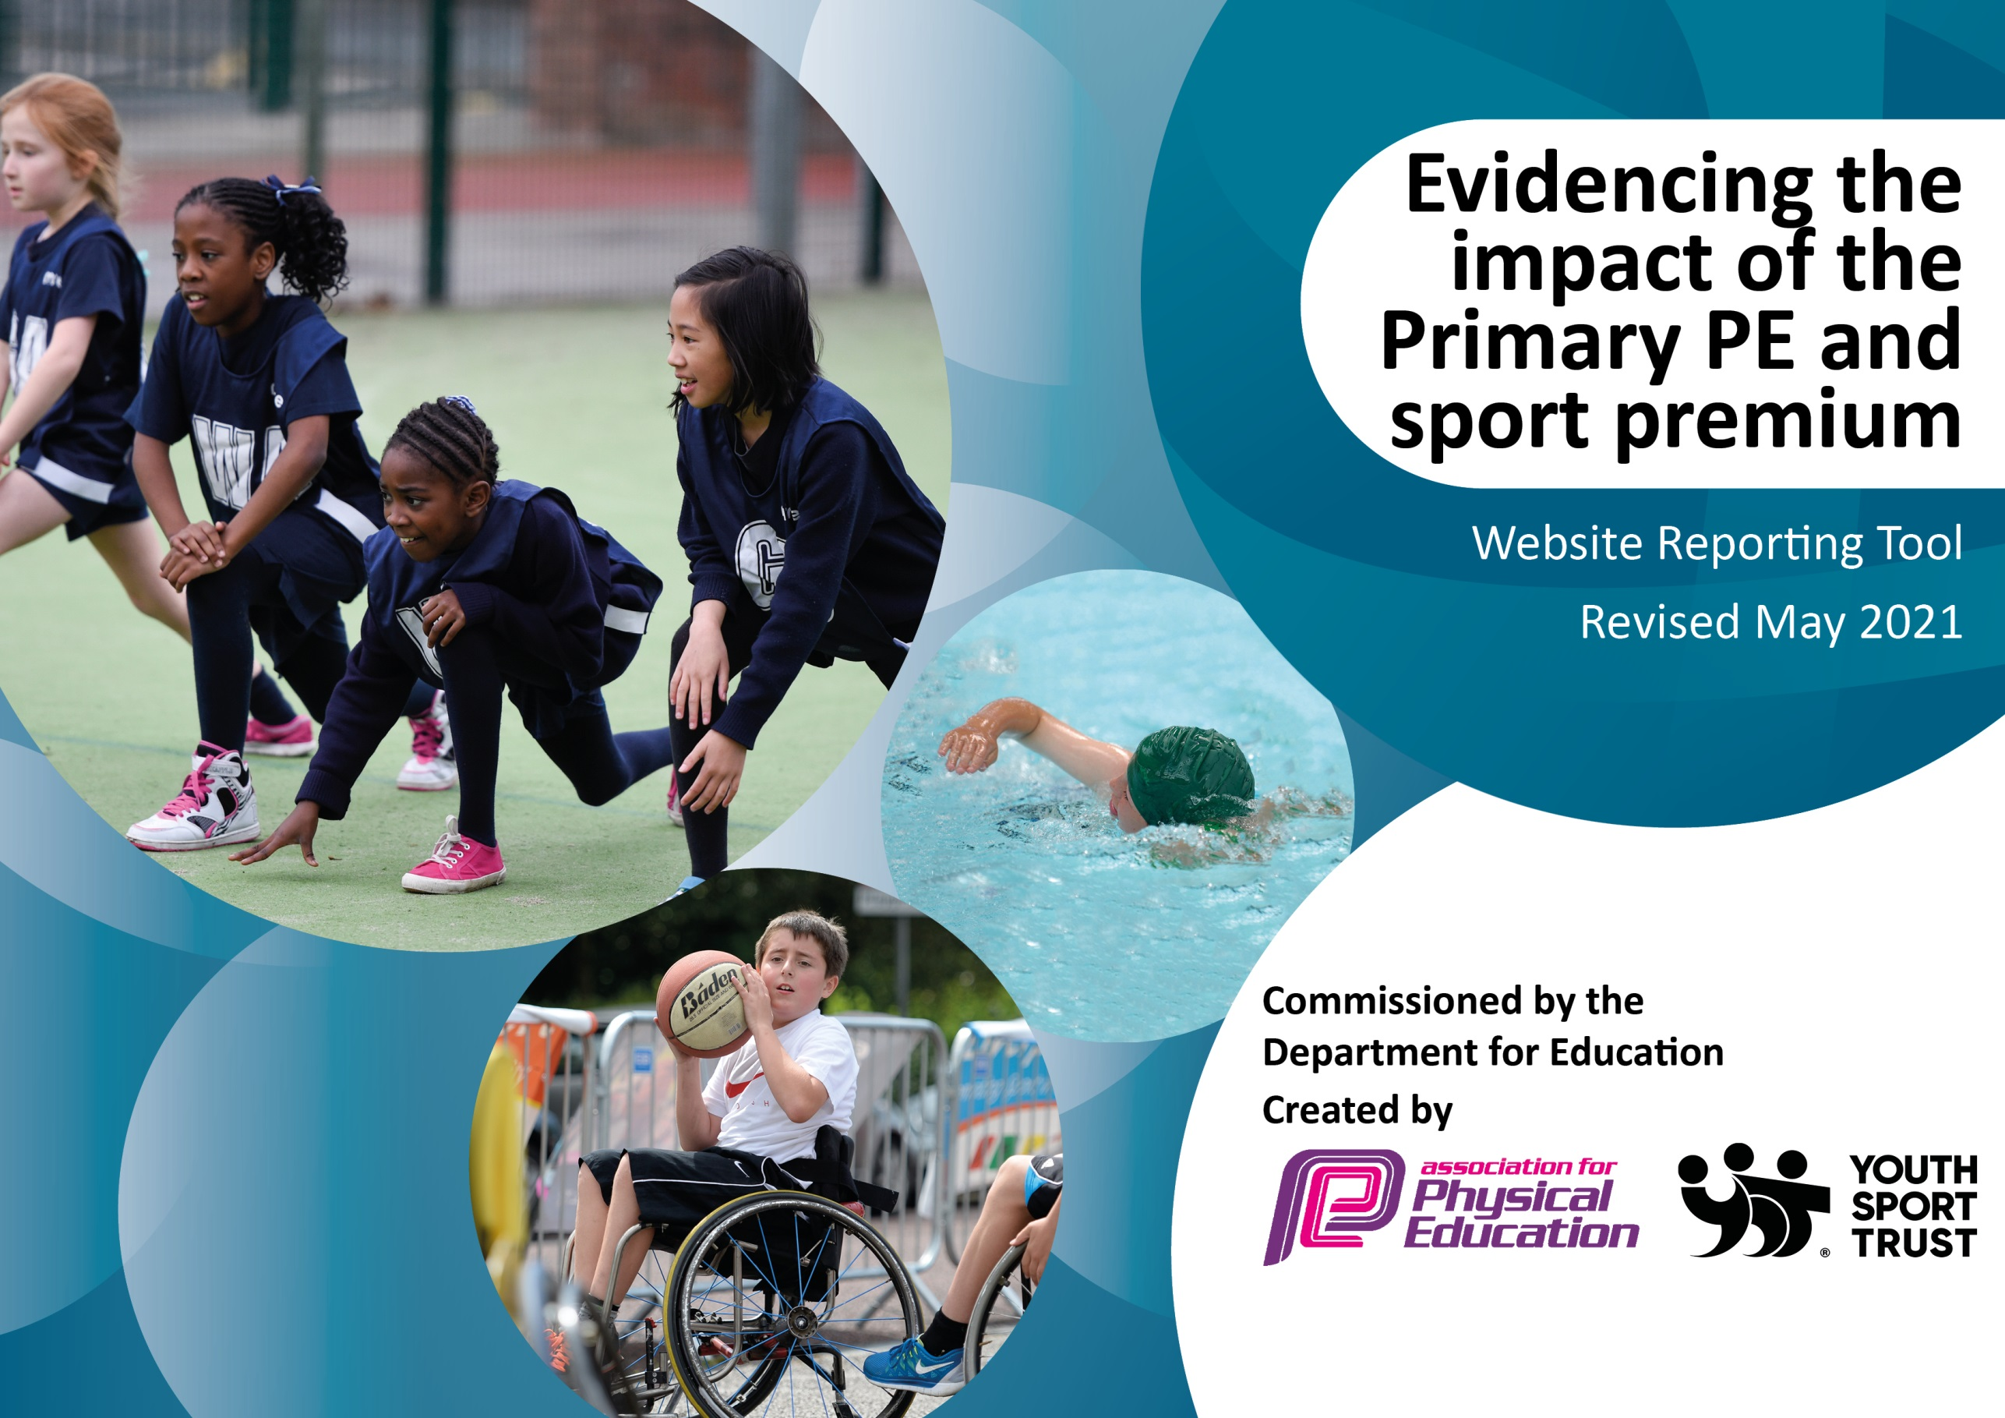

It is important that your grant is used effectively and based on school need. The Education Inspection Framework (Ofsted 2019 p64) makes clear there will be a focus on ‘whether leaders and those responsible for governors all understand their respective roles and perform these in a way that enhances the effectiveness of the school’.

Under the Quality of Education criteria (p41) inspectors consider the extent to which schools can articulate their curriculum (INTENT), construct their curriculum (IMPLEMENTATION) and demonstrate the outcomes which result (IMPACT).

To assist schools with common transferable language this template has been developed to utilise the same three headings which should make your plans easily transferable between working documents.

Schools must use the funding to make additional and sustainable improvements to the quality of Physical Education, School Sport and Physical Activity (PESSPA) they offer. This means that you should use the Primary PE and sport premium to:

- Develop or add to the PESSPA activities that your school already offer
- Build capacity and capability within the school to ensure that improvements made now will benefit pupils joining the school in future years
- The Primary PE and sport premium should not be used to fund capital spend projects; the school’s budget should fund these.
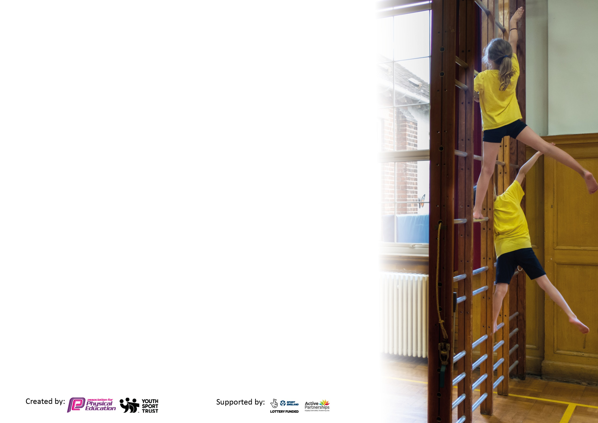
Please visit gov.uk for the revised DfE guidance including the 5 key indicators across which schools should demonstrate an improvement. This document will help you to review your provision and to report your spend. DfE encourages schools to use this template as an effective way of meeting the reporting requirements of the Primary PE and sport premium.

We recommend you start by reflecting on the impact of current provision and reviewing the previous spend.

Schools are required to publish details of how they spend this funding, including any under-spend from 2019/2020, as well as on the impact it has on pupils’ PE and sport participation and attainment by the end of the summer term or by 31st July 2021 at the latest.

We recommend regularly updating the table and publishing it on your website throughout the year. This evidences your ongoing self-evaluation of how you are using the funding to secure maximum, sustainable impact. Final copy must be posted on your website by the end of the academic year and no later than the 31st July 2021. To see an example of how to complete the table please click HERE.

Please note: Although there has been considerable disruption in 2020 it is important that you publish details on your website of how you spend the funding - this is a legal requirement.
Support for review and reflection - considering the 5 key indicators from DfE, what development needs are a priority for your setting and your pupils now and why? Use the space below to reflect on previous spend and key achievements and areas for development.

N.B. In this section you should refer to any adjustments you might have made due to Covid-19 and how these will influence further improvement.
Key achievements to date until July 2020: | Areas for further improvement and baseline evidence of need:
Participation in a range of sporting events including more in-school sporting events and festivals (some virtual and some face to face).  Committed coaches delivering high quality PE.  New resources to aid the teaching of PE.  Staff training and CPD opportunities.  Changes to the health and fitness of children.  The Daily Mile.  Teach Active.  Promotion of the physical and mental well-being of each child.  PhunkyFoods and PhunkyFit. | More sporting after school clubs.  Continue to improve the health and fitness of children.  Further opportunities for children to achieve 30:30 (promoting external clubs).  Re-train play-leaders.  CPD for a wider range of staff.  Continue to encourage active travel (Modeshift Stars)  Praise and celebrate sporting achievements

Did you carry forward an underspend from 2020-2021 academic year into the current academic year? YES
Total amount carried forward from 2020-2021 £6076.50
+ Total amount for this academic year 2021-2022 £17,500
= Total to be spent by 31st July 2022 £23,576.50
Meeting national curriculum requirements for swimming and water safety.  N.B Complete this section to your best ability. For example you might have practised safe self-rescue techniques on dry land which you can transfer to the pool when school swimming restarts.  Due to exceptional circumstances priority should be given to ensuring that pupils can perform safe self rescue even  if they do not fully meet the first two requirements of the NC programme of study. | Children will not swim this year until the Summer term – This section will be updated later in the academic year.
What percentage of your current Year 6 cohort swim competently, confidently and proficiently over a distance of at least 25 metres?  N.B. Even though your pupils may swim in another year please report on their attainment on leaving primary school at the end of the summer term 2021.  Please see note above. | %
What percentage of your current Year 6 cohort use a range of strokes effectively [for example, front crawl, backstroke and breaststroke]?  Please see note above. | %
What percentage of your current Year 6 cohort perform safe self-rescue in different water-based situations? | %
Schools can choose to use the Primary PE and sport premium to provide additional provision for swimming but this must be for activity over and above the national curriculum requirements. Have you used it in this way? | Yes/No

Action Plan and Budget Tracking
Capture your intended annual spend against the 5 key indicators. Clarify the success criteria and evidence of impact that you intend to measure to evaluate for pupils today and for the future.

Academic Year: 2021/2022 | Total fund allocated: £17,500 | Date Updated: October 2021
Key indicator 1: The engagement of all pupils in regular physical activity – Chief Medical Officers guidelines recommend that primary school pupils undertake at least 30 minutes of physical activity a day in school |  |  |  | Percentage of total allocation:
 |  |  |  | %
Intent | Implementation |  | Impact
Your school focus should be clear what you want the pupils to know and be able to do and about  what they need to learn and to  consolidate through practice: | Make sure your actions to achieve are linked to your intentions: | Funding allocated: | Evidence of impact: what do pupils now know and what can they now do? What has changed?: | Sustainability and suggested next steps:
All children will participate in 2 hours of quality PE each week.  Year 5 and 6 children will become play-leaders and work alongside the mid-days to lead active games.  Active Lessons  Active Travel  Specialist Coaches  Swimming | Use of quality resources, PE schemes of work and professional coaches.  Play-leader training. Quality resources.  Subscription to Active Teach. PE leader to monitor this.  Modeshift Stars  To continue working alongside WrightSports and PEasy.  Year 6 catch up recovery programme in the Summer term. |  | High quality teaching, covering a range of skills.  Children engaged in active games during playtimes and lunchtimes. Being active through playing.  This build-ups the 30 minutes of activity in school per day, excluding PE lessons and playtimes. This is promoting physical activity through learning.  Encouraging children and families to walk/cycle to school to promote an active lifestyle.  To deliver specialist areas of the curriculum and provide CPD opportunities for staff, through observations.  Year 6 focus – catch up skills to make up for lost lessons during Covid. To provide children with the opportunity to learn to swim and train them in water safety and rescue.
Key indicator 2: The profile of PESSPA being raised across the school as a tool for whole school improvement |  |  |  | Percentage of total allocation:
 |  |  |  | %
Intent | Implementation |  | Impact
Your school focus should be clear what you want the pupils to know and be able to do and about  what they need to learn and to  consolidate through practice: | Make sure your actions to achieve are linked to your intentions: | Funding allocated: | Evidence of impact: what do pupils now know and what can they now do? What has changed?: | Sustainability and suggested next steps:
Praise and celebrate children’s sporting achievements both in and out of school during Golden Time Assembly.  PE noticeboard  PE values linked to other subjects – Active Teach.  Facebook celebrations  PE newsletter | Celebrate sporting achievements during weekly Golden Time Assembly.  Create a PE noticeboard to display photos, certificates, and notices.  Staff make lessons active when they can and link lessons to the school values.  Sporting achievement photos and notices to be posted on school Facebook page.  Send out a PE newsletter each term. |  | Boosts self-esteem – supports mental health and well-being. Promotes local clubs and may persuade other children to take part and become more active.  Working towards 30:30 and making lessons active so the less active are physical, without realising. Targets all children.  Involving families and the wider community. Celebrating activity.

Key indicator 3: Increased confidence, knowledge and skills of all staff in teaching PE and sport |  |  |  | Percentage of total allocation:
 |  |  |  | %
Intent | Implementation |  | Impact
Your school focus should be clear | Make sure your actions to | Funding | Evidence of impact: what do | Sustainability and suggested
what you want the pupils to know | achieve are linked to your | allocated: | pupils now know and what | next steps:
and be able to do and about | intentions: |  | can they now do? What has
what they need to learn and to |  |  | changed?:
consolidate through practice:
PLT Meetings – Maryport Cluster.  Staff Training  Schemes of work  Specialist Coaches | PE lead to attend regular PLT meetings (both virtual and face-to-face) and feedback the updates to all staff.  PE lead will attend training organised through the cluster and feedback where necessary. Additional staff CPD when available. Staff will approach PE lead if there is an area they would like to further develop.  Continue using The PE Hub and Active Teach. Use Kids Love Yoga to support staff with the delivery of this.  Continue with Wright Sport services coaches and Sarah Hampson from PEasy. |  | Schools in the area sharing good practice and keeping up to date with any changes and new initiatives.  Better subject knowledge and confidence teaching PE. Higher quality lessons. Children will get more from the lesson.  Consistent and progressive planning following the skills progression documents. Children are getting a full coverage of PE and all the required skills.  Specialist coaches delivering in their area of expertise. Provides more opportunities for the children. Staff can learn and move forward in this area.
Key indicator 4: Broader experience of a range of sports and activities offered to all pupils |  |  |  | Percentage of total allocation:
 |  |  |  | %
Intent | Implementation |  | Impact
Your school focus should be clear | Make sure your actions to | Funding | Evidence of impact: what do | Sustainability and suggested
what you want the pupils to know | achieve are linked to your | allocated: | pupils now know and what | next steps:
and be able to do and about | intentions: |  | can they now do? What has
what they need to learn and to |  |  | changed?:
consolidate through practice:
Additional achievements:  Workshops/events/whole school PE days.  Competitions  Sports Clubs  Links with other schools | Whole school fitness day, bikeability, phunkyfit activities, Active Teach lessons, KidzFit booking, wheelchair basketball?  Continue taking part in competitions within the cluster (Spring term onwards). Termly in-school events and festivals.  Competitions and events with the MAT.  A wider range of sports after school clubs.  Links with the other schools within The MAT. Links with feeder schools. |  | Providing extra opportunities.  Targeting the 30:30. Targeting all children, including the less active and the non-active.  The sessions might instil a love in a new area of sport.  Opportunities to compete. Children can excel in certain areas.  Further opportunities.  Builds professional partnerships with other schools. Makes good links with feeder schools and prepares children for the move to secondary schools.

Key indicator 5: Increased participation in competitive sport |  |  |  | Percentage of total allocation:
 |  |  |  | %
Intent | Implementation |  | Impact
Your school focus should be clear | Make sure your actions to | Funding | Evidence of impact: what do | Sustainability and suggested
what you want the pupils to know | achieve are linked to your | allocated: | pupils now know and what | next steps:
and be able to do and about | intentions: |  | can they now do? What has
what they need to learn and to |  |  | changed?:
consolidate through practice:
Intra and Inter competitions (Maryport cluster and Allerdale)  Extend competitions to B teams where possible.  Events between the other Primary schools within The MAT. | Organise and attend a range of events for each year group/ability of children (inclusive). These to include festivals of fun.  Where possible, send multiple teams to a competition.  Dearham, Arlecdon, Thornhill and West Lakes Academy. |  | In-school events – targets all children.  Cluster competitions – provides opportunities to compete and develop in specific areas.  Targets the less active. Gives all children the opportunity to take part.  Good links, mixing with a range of children of all abilities.

Signed off by
Head Teacher:
Date:
Subject Leader:
Date:
Governor:
Date:

